**THE REPUBLIC 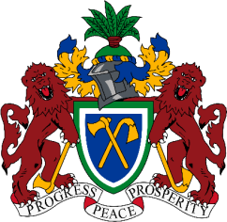 OF THE GAMBIA**

**MINISTRY OF HEALTH**

**BRIKAMABA MINOR HEALTH CENTRE**

**LOWER FULLADU WEST DISTRICT**

**CENTRAL RIVER REGION**

**2nd DECEMBER 2021**

**TO WHOM IT MAY CONCERN**

**REFERENCE FOR ANNA MARIE A. MENDY**

I had the joy and satisfaction of working successfully with **ANNA MARIE,** following the completion of her grade twelve. She has been volunteering in the health facility under supervision of nurses in all cadres and she has demonstrated her intellectual ability and determination of been a good nurse in the future. Due to her quick level of understanding, she was able to conduct basic nursing procedures and sometimes assigned to carry out some tasks under supervision. She has worked in various units OPD, Pharmacy, Lab, maternity etc. she has vast understanding in various unit and she sometimes do on call services at the Lab more especially when the lab personnel is not around.

**ANNA MARIE** has an outstanding character of being very respectful to authority and has been abiding by the rules and regulations of the institution. She is very quick to execute any assignment given to him in a very abiding manner. She has a very cordial working relationship with the rest of the staff in the facility.

She is also blessed to be very fluent in many languages both local and official languages which gave her the advantage in terms of his communication skills. Her work ethics are unquestionable as far as the work is concern.

With the above mentioned, I am quite sure that if she is given the opportunity in any institution, she would definitely showcase her talents and skills in academics. She is highly recommended.

Yours faithfully

………………….

**Madinatou Barry**

**OIC**

**Tel: 3041554/7137083**