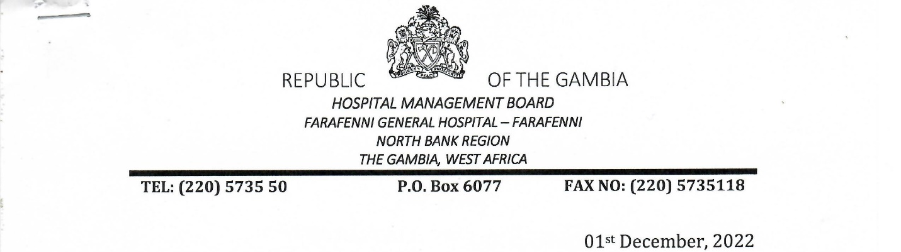

FGH HMB/PF/6000563(426)

Omar M Jallow

Nurse Attendant

Farafenni General Hospital

Farafenni

**CONFIRMATION IN APPOINTMENT**

This is to inform you that the Hospital Management Board has approved your confirmation in appointment in the Permanent and Pensionable Establishment with effect from 01st June 2022.

