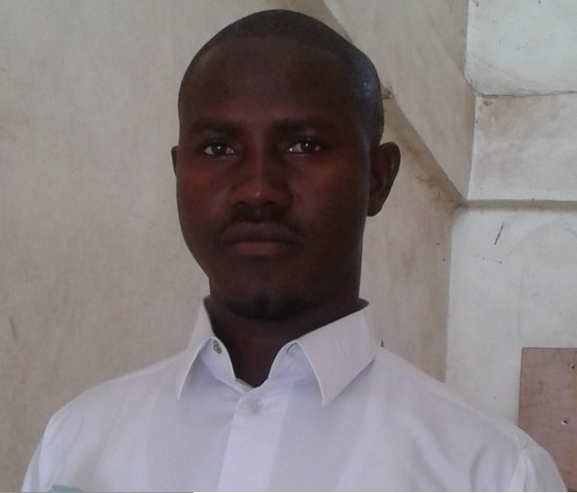
CURRICULUM VITAE
PERSONAL DATA
Name: SEEDY M. BAYO
Gender: Male
Date of Birth: 11th April, 1985
Place of Birth: Fulladu Tabanani Village (CRR)
Address: Sukuta Nema Village, Kombo North, West Coast Region
Nationality: Gambian
Language: English, Mandinka and Wolof (Take this just above the Referees)
Marital Status: Married
Phone Number: (220) 7708279/6870942/7298533/6936362
E-mail Address: bayoseedy@yahoo.com or bayoseedy@hotmail.com
EDUCATION:
LASTING SOLUTION INSTITUTE
Jan. 2018-April. 2018 Waiting Diploma in Database Management
WEST AFRICA COMMUNITY DEVELOPMENT TRAINING CENTER
Aug. 2012-Sept. 2012 Management and Development
April 2012-May 2012 Economics and Development
Jan. 2012-Feb. 2012 Human Relation and Development
Nov. 2011-Dec. 2011 Community Development Foundation HUMANITY FIRST THE GAMBIA INSTITUTE
Mar. 2011-Sept.2011 Diploma in Hardware and Operating System Nov. 2009-May. 2010 Advance Diploma in Information Technology
Oct. 2008-Jan. 2009 Diploma in Information Technology
Jan. 2008-April. 2008 Certification Information Technology
SECONDARY SCHOOL
Sept. 2004-May 2007 Daddy Jobe Comprehensive School (WASSCE)
Sept. 2001-May 2004 Brikama-Ba Upper Basic School (GABECE)
CARREE OBJECTIVE
To build a progressive and dynamic career in all development agendas, agriculture, food security and livelihoods to enhance the quality of life for small holder farmers especially youth, women, and other excluded and marginalized groups. As a change agent my goal is to use policy as an instrument to transform programmatic efforts that alleviate poverty, inequity, injustices and human indignity through facilitating processes that lead to interventions and activities/programmes that could change the live livelihoods of vulnerable groups in the Gambia and beyond, and to contribute to their effective participation in the national economy.

JOB EXPERIENCE:
February 2010-2013:- present: Lecturer (Information Technology)
Humanity First Institute the Gambia Branch
May 2011 and November 2011: Registration officer and polling Staff
Kombo North District and Serrekunda Central
March 2013: Presiding Officer, Independent Electoral Commission (IEC)
November 2013: Facilitator of Training Needed Assessment (TNA)
Central River Region North (CRRN)
West Africa community Development (WACD) with Global environmental fund (Gef)
December 2013-2015: Administration Assistant
West Africa Community Development Training Center (WACD-TC)
June 2014-up to date: Hardware and Operating System (Maintenance & Repairs)
Workshop Technician
January 2016 - March 2016:- Senior Registration Officer (Supervisor)
Kombo South District
Independent Electoral commission (IEC)
December 2016 and April 2017: presiding Officer both presidectcial and perlimentary election
SKILLS:
- Adequate skill in Information Technology
- Adequate skill on Hardware and Operating System
- Ability to solve and handle problem
- Good Public Relation Approach
- Ability to Work in multicultural societies
HOBBIES & AFFILIATIONS:
- Reading novels & Newspapers
- Visiting and meeting Friends
- Sports
REFEREES:
Mr. Saiba Suso
Lecturer, University of the Gambia
P.O. Box 3530
Serrekunda, Email:susosaibak@hotmail.com
Tel: (220) 3650100/6763843/9928824
Mr. Sunkary Badjie
Community development officer (CDO)
Department of Community Development
Brikama office
Serrekunda, Email: sunkary.badjie@yahoo.com
Tel: (220) 9987078/3144279/6987078
Mr. Glulam Ahmad Trawally
Senior Lecturer Humanity First Institute, Gambia Branch
Tel: (220) 9872435
CERTIFICATION:
I Seedy M. Bayo do hereby testifying to the best of my knowledge that, the information above correctly describes my qualification and experiences.
SIGNATURE DATE
Seedy M. Bayo 05-12-2018

