***Postal Address:*** *PMB 144*



***Telephone:*** *(220)4484812*

***General Office:*** *(220)4483136*

***Fax:*** *4483224*

***E-mail:*** [*registrar@gambiacollege.edu.gm*](mailto:registrar@gambiacollege.edu.gm)

***Website:*** [*www.gambiacollege.edu.gm*](http://www.gambiacollege.edu.gm/)

PRINCIPAL: Aboubacarr Jallow

Oct 13, 2022

# Mr Hammed Jamanka

GC #: **22221247**

RE: OFFER OF PLACE IN THE ADV. DIPLOMA IN EDUCATION (SECONDARY)

I have the pleasure to inform you that you have **offered a place** in **SCHOOL OF EDUCATION** of Gambia College to study for the ADV. DIPLOMA IN EDUCATION (SECONDARY) programme commencing in **October 2022** .

The College makes the offer on the understanding that:

1. As a student, you are required to pay a tuition fee of **D12,000.00** per annum which is subjected to revision, other charges (internet, medical and student dues) of one thousand six hundred dalasis **(D1600.00)** . This is payable enbloc or in two equal instalments upon receipt of admission letter before registration. Payment shall be made to Gambia College’s **EcoBank, Account No: 0070134904111201 or GT-Bank, Account No: 204-265722-110. Note: Medical fees (500.00) be paid to Helena’s account and student union dues (100.00 per year) to paid to student union**
2. You are coming as full time student and as such, you would be doing the programme for 3 years. You are required to have at least **90%** attendance
3. The course is non-residential and you would be responsible for your own accommodation, stationery as well as wear the school of education uniform (Black trousers/skirt and white shirt).

# You must attain a cumulative grade point average (CGPA) of 2.50 in all assessments and examinations, failing which you may be withdrawn from the programme.

1. During the training, you would be required to be on teaching practice and could be posted to any school in the country for a period to be determined by the College.
2. As student you are not to engage yourself in any activity that will jeopardize the academic activities or tranquillity of the College, failure of which you will be asked to withdraw from the programme.
3. In accepting the offer, you must undertake to observe the statue of the college and also abide by the rules and regulations the college makes for its students from time to time

I would be grateful if you would let us know by writing whether or not you wish to accept the offer. In the hope that you will accept this offer of a place, I wish you a happy and successful study at Gambia College.

***You are to report to the College for orientation and registration on the 3rd of October 2022***

Yours sincerely

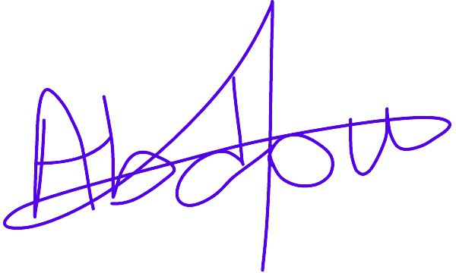

# DIRECTOR OF ADMISSION AND FINANCIAL AID

**Abdoulie M. Bah**

# Email [:ambah@gambiacollege.edu.gm](mailto:ambah@gambiacollege.edu.gm)