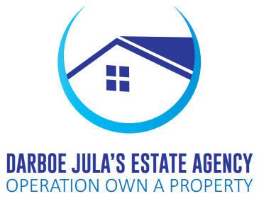

Darboe Jula’s Estate Agency  
 Brikama,  
 Behine Jah Oil Petrol station  
 Nyambai Highway  
 Brikama,  
 April ,6 2018.

**NOTICES LETTER TO THE TENANT AT BRIKAMA CARREFOUR PLAZA**

This letter from Darboe Jula’s estate agency Brikama; we hereby notify you to pay your monthly rents of the previous months which were long overdue. Payments must be done before the Friday 20th day of April 2018 and failure to pay on this day, you shall consider this as notice of eviction which shall run for only one month commencing from the day you received this notice.

The landlord is not having any business with the plaza now, any business you have to go to Darboe Jula’s office at Brikama or you contact the following numbers 2187171/3781839.

THANKS YOU:

Branch Manager

………………………..  
 Ousman Jafuneh